
Touchstones Project
Netcards

Wintering Netcards with Text

Autumn Leaf and Snow HRJ
Blizzard HRJ
Candles in Winter HRJ
Cat at Window HRJ

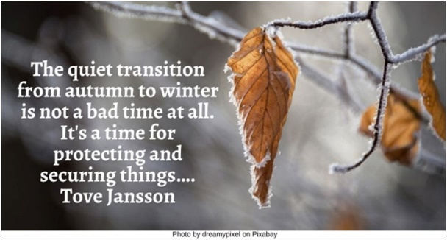

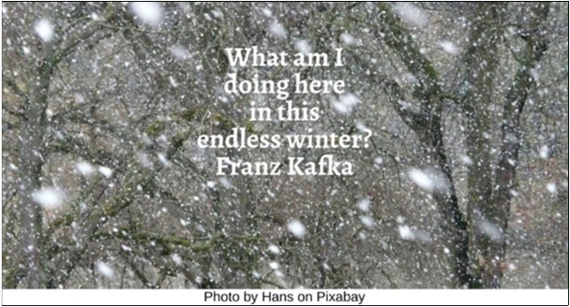

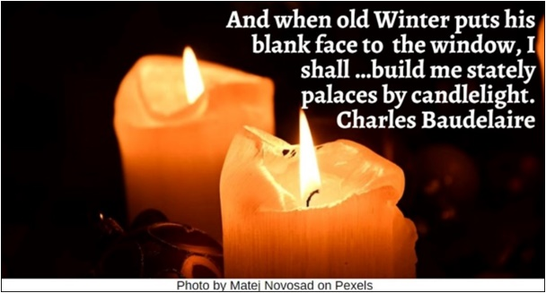

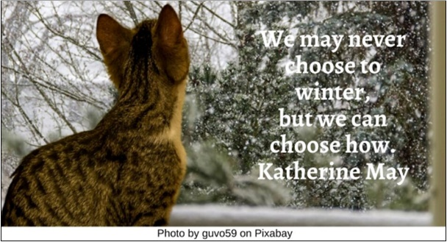

Cold HRJ
Crucible of Winter HRJ
Dreams HRJ
Endless Winter HRJ

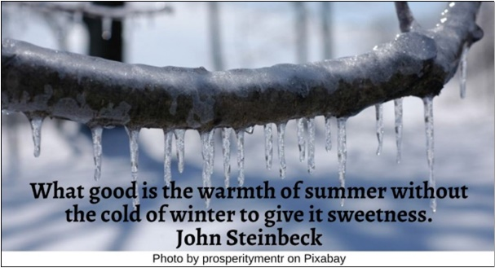

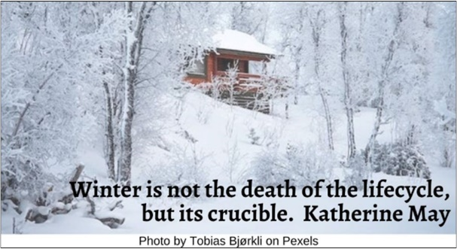

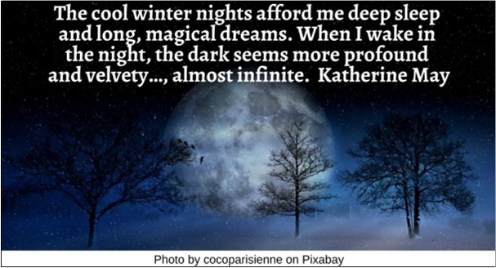

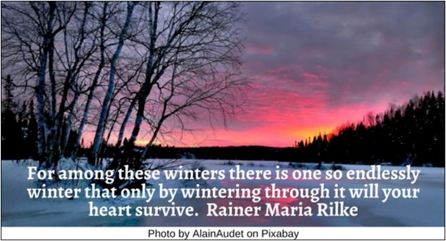

Enjoying Winter HRJ
Falling Leaves HRJ
Fireplace HRJ
Grasshopper HRJ

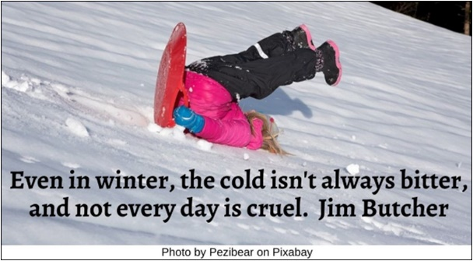

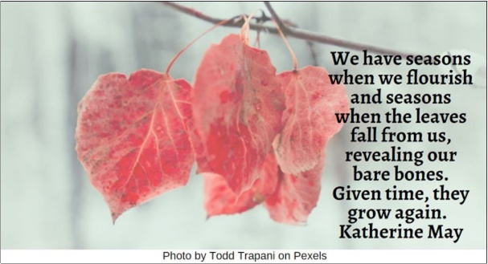

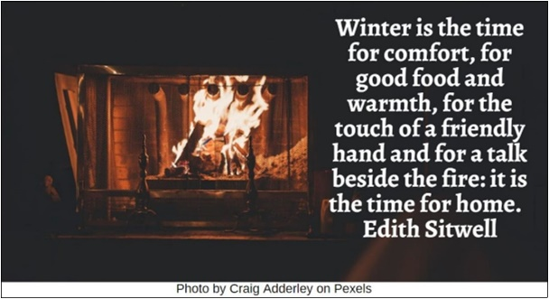

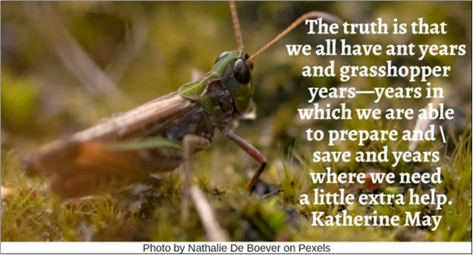

Heart Winter HRJ
House in Winter HRJ
Knife HRJ
Library HRJ

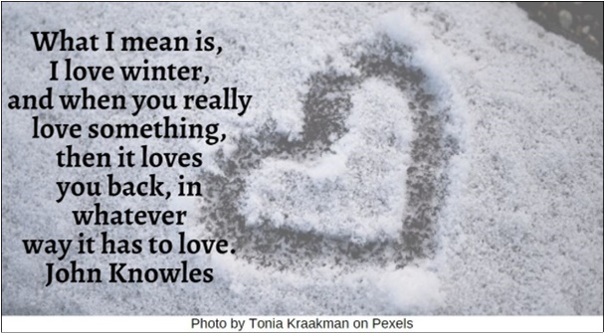

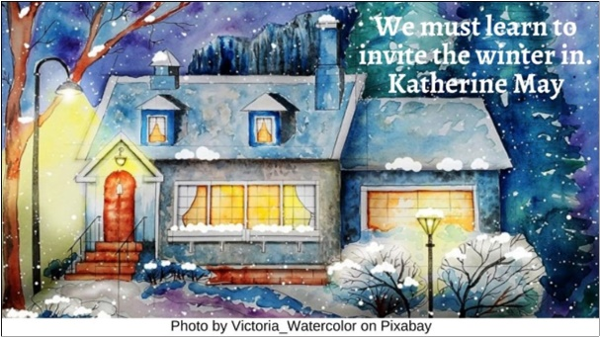

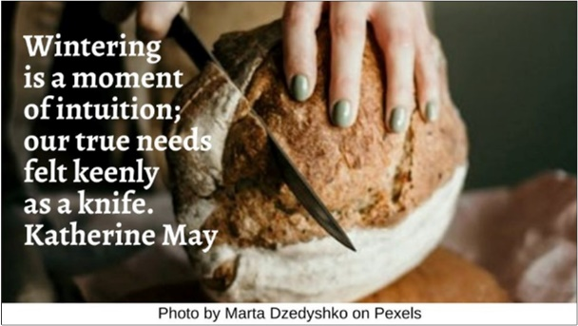

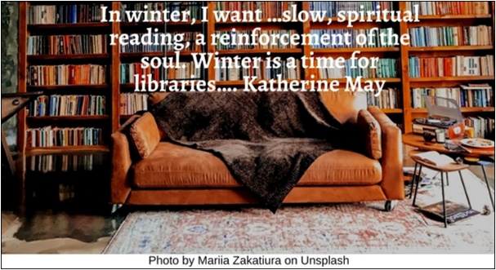

Melting Icicles HRJ
Metronome HRJ
Protest in Winter HRJ
Rabbit in Snow HRJ

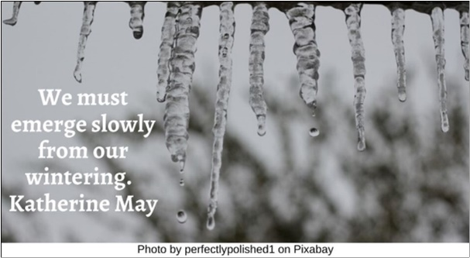

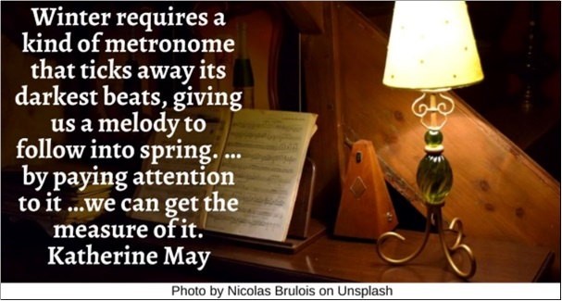



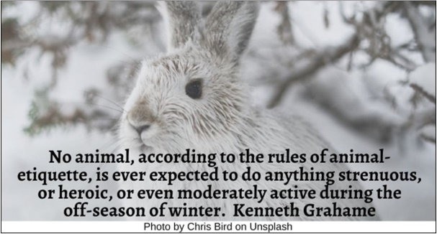

Skiing HRJ
Snow HRJ
Solitude in Winter HRJ
Sunlight in Winter HRJ

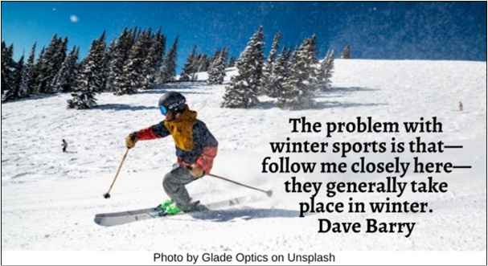

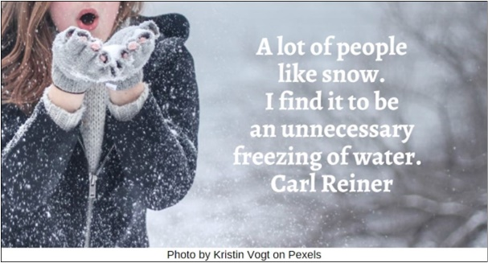

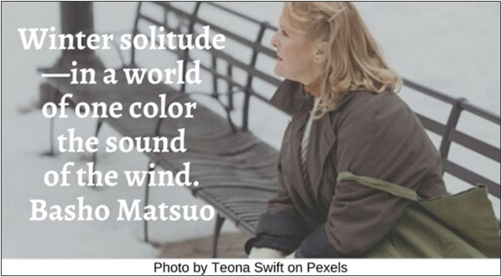

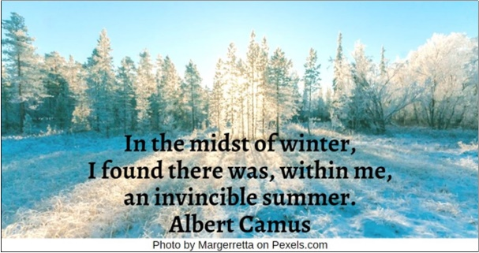

Sunset in Winter HRJ
Tree in Winter HRJ
Winter at Home HRJ
Winter Landscape HRJ

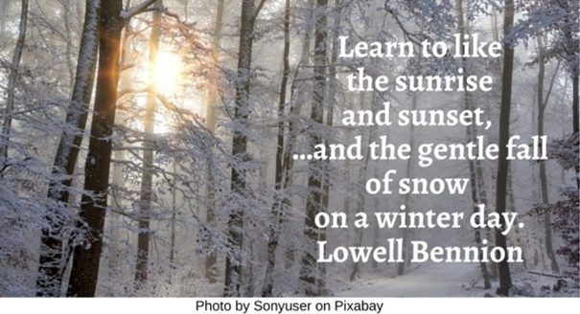

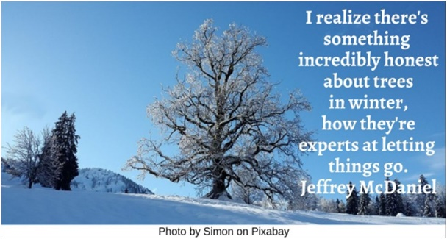

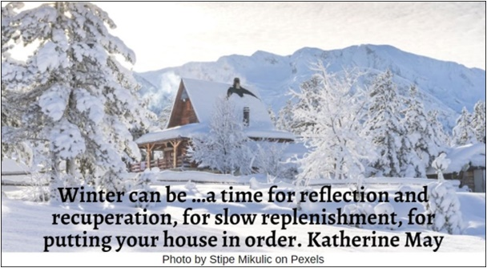

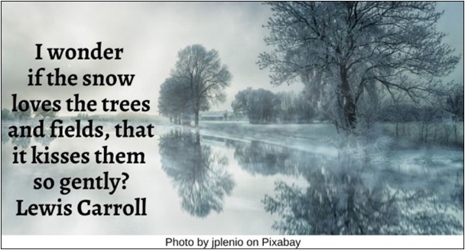

Winter Wisdom HRJ
Wolf in Winter HRJ
Woman in Winter HRJ

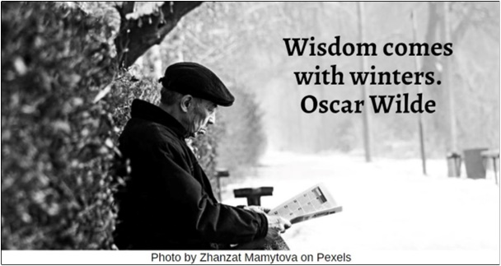

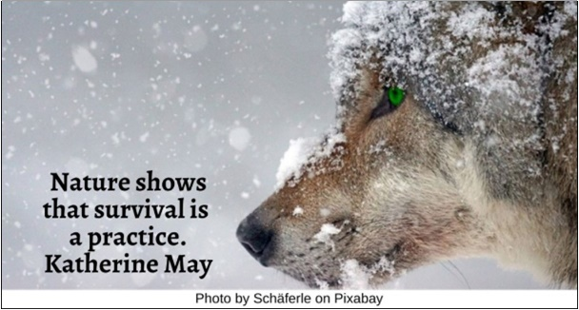

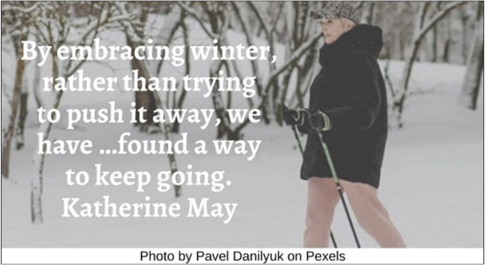

Text of Quotes
Autumn Leaf and Snow HRJ
The quiet transition from autumn to winter is not a bad time at all. It's a time for protecting and securing things…. Tove Jansson

Blizzard HRJ
What am I doing here in this endless winter? Franz Kafka

Candles in Winter HRJ
And when old Winter puts his blank face to the window, I shall …build me stately palaces by candlelight. Charles Baudelaire

Cat at Window HRJ
We may never choose to winter, but we can choose how. Katherine May

Cold HRJ
What good is the warmth of summer without the cold of winter to give it sweetness. John Steinbeck

Crucible of Winter HRJ
Winter is not the death of the life cycle, but its crucible. Katherine May

Dreams HRJ
The cool winter nights afford me deep sleep and long, magical dreams. When I wake in the night, the dark seems more profound and velvety…, almost infinite. Katherine May

Endless Winter HRJ
For among these winters there is one so endlessly winter that only by wintering through it will your heart survive. Rainer Maria Rilke

Enjoying Winter HRJ
Even in winter, the cold isn't always bitter, and not every day is cruel. Jim Butcher

Falling Leaves HRJ
We have seasons when we flourish and seasons when the leaves fall from us, revealing our bare bones. Given time, they grow again. Katherine May

Fireplace HRJ
Winter is the time for comfort, for good food and warmth, for the touch of a friendly hand and for a talk beside the fire: it is the time for home. Edith Sitwell

Grasshopper HRJ
The truth is that we all have ant years and grasshopper years—years in which we are able to prepare and save and years where we need a little extra help. Katherine May

Heart in Winter HRJ
What I mean is, I love winter, and when you really love something, then it loves you back, in whatever way it has to love. John Knowles

House in Winter HRJ
We must learn to invite the winter in. Katherine May

Knife HRJ
Wintering is a moment of intuition; our true needs felt keenly as a knife. Katherine May

Library HRJ
In winter, I want …slow, spiritual reading, a reinforcement of the soul. Winter is a time for libraries…. Katherine May

Melting icicles HRJ
We must emerge slowly from our wintering. Katherine May

Metronome HRJ
Winter requires a kind of metronome that ticks away its darkest beats, giving us a melody to follow into spring. …by paying attention to it …we can get the measure of it. Katherine May

Protest in Winter HRJ
Now is the winter of our discontent. William Shakespeare

Rabbit in Snow HRJ
No animal, according to the rules of animal-etiquette, is ever expected to do anything strenuous, or heroic, or even moderately active during the off-season of winter. Kenneth Grahame

Skiing HRJ
The problem with winter sports is that—follow me closely here—they generally take place in winter. Dave Barry

Snow HRJ
A lot of people like snow. I find it to be an unnecessary freezing of water. Carl Reiner

Solitude in Winter HRJ
Winter solitude— / in a world of one color / the sound of the wind. Basho Matsuo

Sunlight in Winter HRJ
In the midst of winter, I found there was, within me, an invincible summer. Albert Camus

Sunset in Winter HRJ
Learn to like the sunrise and sunset, …and the gentle fall of snow on a winter day. Lowell Bennion

Tree in Winter HRJ
I realize there's something incredibly honest about trees in winter, how they're experts at letting things go. Jeffrey McDaniel

Winter at Home HRJ
Winter can be …a time for reflection and recuperation, for slow replenishment, for putting your house in order. Katherine May
Winter Landscape HRJ
I wonder if the snow loves the trees and fields, that it kisses them so gently? Lewis Carroll

Winter Wisdom HRJ
Wisdom comes with winters. Oscar Wilde

Wolf in Winter HRJ
Nature shows that survival is a practice. Katherine May

Woman in Winter HRJ
By embracing winter, rather than trying to push it away, we have …found a way to keep going. Katherine May

